Can we change this?

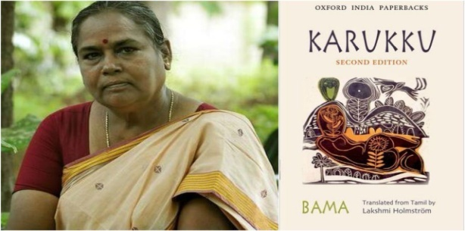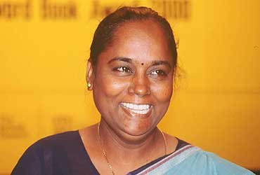

Bama (born 1958), also known as Bama Faustina Soosairaj, is a Tamil, Dalit feminist, committed teacher and novelist. She rose to fame with her autobiographical novel Karukku (1992), which chronicles the joys and sorrows experienced by Dalit Christian women in Tamil Nadu.^{[1]} She subsequently wrote two more novels, Sangati (1994) and Vanmam (2002) along with two collections of short stories: Kusumbukkaran (1996) and Oru Tattvum Erumaiyum (2003).^{[2]} In addition to this she has written twenty short stories.
Bama was born in 1958 as Faustina Mary Fatima Rani in a Roman Catholic family belonging to the Paraiyar community from Puthupatti in the then Madras State.^{[1]} Later she accepted 'Bama' as her pen name. Her father, Susairaj was employed in the Indian Army^{[3]} and her mother was named Sebasthiamma. She is the sister of famous Dalit writer Raj Gauthaman. Bama's grandfather had converted from Hinduism to Christianity.^{[1]} Bama's ancestors were from the Dalit community and worked as agricultural labourers. Bama had her early education in her village. Her early literary influences include Tamil writers like Jayakantan, Akhilan, Mani, and Parthasarthy. In college, she read and enjoyed Kahlil Gibran and Rabindranath Tagore. On graduation, she became a schoolteacher for very poor girls, following which she served as a nun for seven years.^{[3]} She chose to take the holy orders to escape caste-based discrimination, and also to further her mission of helping in the advancement of poor Dalit girls.
Born | Faustina Mary Fatima Rani  1958 (age 60–61)  Pudhupatti, Chennai, India
Nationality | Indian.
Occupation | writer, teacher.

